# CS 255 System Design Document Template

## UML Diagrams

### UML Use Case Diagram

### UML Sequence Diagram

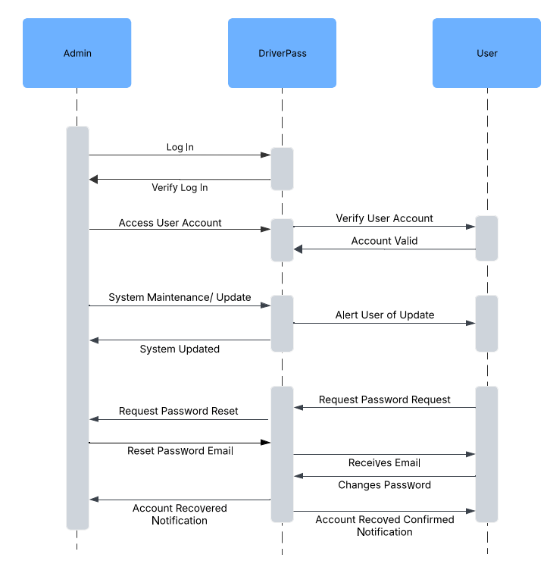

### UML Class Diagram

## Technical Requirements

The technical requirements for the host (DriverPass (DP)) would include things like; access to a computer or laptop with reliable internet access, keyboard, mouse, any cords, at least one monitor, docking station, at least one server to run the DP system and personally I would use a VPN to ensure extra safety. These are all hardware items the host might need. Some of the software requirements would be the actual DP software, your computer must have an operating system like Windows or Mac and lastly some kind of security software installed. There is a lot of sensitive information in the system that should be protected as best we can. The host is just one side of things however, the Client or the customer side will also need some hardware and software requirements as well. Those requirements look like; computer or laptop with reliable internet connection, access to electricity, your cell phone can be helpful for any necessary information and a pair of headphones if you are using public Wi-Fi could also be helpful. As for software the customer will need the DP software, their choice of web browser (Chrome, Edge, etc.), the note pad app to take notes if needed, an operating system like Windows or MacOS, a VPN is also highly recommended especially if on public Wi-Fi. Lastly, the development tools and infrastructure required are a computer with an IDE - the programming software like Eclipse or PyCharm and internet access, as mentioned above. The infrastructure required would be the server location or cloud access.